Garlic Potato Snack
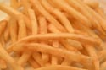
1 (12oz) Pkg. Frozen French Fries
2 cloves garlic, minced 2 T. grated parmesan cheese
1/2 t. Van Roehling Yard Bird Chicken Rub
1 jar Cheese Whiz
Arrange potatoes on baking sheet in single layer.
Bake @ 450 for 5 min. Combine garlic, parmesan cheese,
and Van Roehling Cheezy Italian Seasoning, and sprinkle
over potatoes and toss. Bake an additional 5 min. or until
crisp. Serve warm with Cheese Whiz as dip.

Deli - Rye Snacks
1 lb. ground beef 1 lb. ground sausage
1 lb. Velvetta cheese 3 t. Van Roehling Sizzlin'
1 loaf Deli-Rye bread Oak Steak Rub
Brown meats in skillet. Drain. Put meats back in skillet,
add Van Roehling Sizzlin' Oak Steak Rub and cheese.
Mix well until melted. Spread mixture on slices of Deli-Rye
bread. Heat in oven @ 350 until hot and serve, or may
be frozen until ready to heat.

Joe's Ham Salad
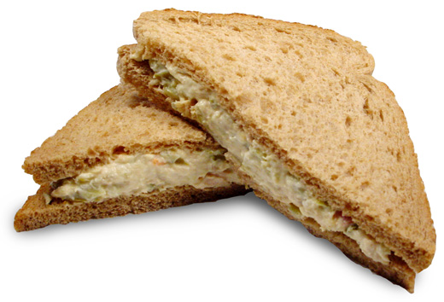
1(16oz) Pkg Beef Bologna 1/4c. Mayonnaise
2 t. Sweet Pickle Relish 1 sm. onion, chopped
2 t. Van Roehling Sweet Piggy Pork Rub
Grate bologna, add remaining ingredients. Mix well.
Serve on bread or buns.
Grated cheese may be added also, and for a little
kick, replace the pickle relish, with Van Roehling
Texas Jalapeno Sweeties, chopped.

Pizza Biscuit Pockets
1 can large biscuits 3/4 c chopped ham, deli meat or pepperoni
3/4 c. shredded cheese 1 small can tomato sauce
3 t. Van Roehling Cheezy Italian Seasoning
Press each biscuit into a 5" round. Put approximately 1/2 T. each of meat and
cheese onto each biscuit round. Fold over and seal edges with fork. Bake @
400 for 10-13 min. Meanwhile, mix tomato sauce and Van Roehling Cheezy
Italian Seasoning. Heat through. Serve with biscuit pockets for dipping.

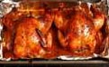
Honey Hens
4 Cornish Hens 1/2 c. butter, melted
3/4 c. Van Roehling Honey Jalapeno Sauce
Preheat oven to 350. Combine butter and Van
Roehling Honey Jalapeno Sauce. Pour over
hens and bake 1 1/4 hours, basting every 15 min. until
tender. Serve 1/2 hen or 1 hen per person.

Sweeties Tortilla Rolls
10 tortillas 4oz. cream cheese
1/4 c. chopped Van Roehling Texas Jalapeno Sweeties
Mix cream cheese and Van Roehling Texas Jalapeno Sweeties.
Spread on each tortilla. Roll each and slice into pinwheels.
Serve.

Cheesy Shrimp Bites
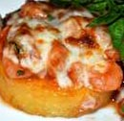
1(4oz) can tiny shrimp, drained 1/2 c. shredded cheese
1/4 lb. mushrooms, finely chopped 1/2 t. lemon juice
2 t. Van Roehling Rod 'N Surf Fish Rub
2 whole grain English Muffins
Preheat oven to 375. Mix all ingredients, except muffins.
Spread mixture on muffins. Cut each into 4 triangles. Place
on baking sheet. Cook in oven about 8 min, or until bubbly.

Zesty Snack Mix
8 T. butter
3T. Van Roehling Yardbird Chicken Rub
3 T. Worcestershire Sauce
1 t. Tabasco Sauce (optional)
3 1/2c. Toasted Corn Cereal
3 1/2c. Toasted Wheat Cereal
3 1/2c. Toasted Rice Cereal
2 c. Pretzel Sticks
2 c. Mixed Nuts
Heat oven to 250. Melt butter in large roasting pan in oven.
Stir in seasonings. Gradually add cereals, nuts, and pretzels,
mixing to coat. Bake 1 hour, stirring every 15 min. Cool on
paper towels. Store in airtight container.

Smoky Cheese Log
1 8oz. Pkg. Cream Cheese
3 t.. Van Roehling Sizzlin' Oak Steak Rub
1/4 c. Cheddar Cheese (shredded)
2-3 Green Onions,
chopped
1/2 c. Pecans, chopped
Set cream cheese out until room temperature. In a large bowl,
mix onions, cheddar cheese, and Van Roehling Sizzlin' Oak
Steak Rub with cream cheese until well blended. Shape into
log and roll in pecans. Chill and serve with wheat crackers.

Date Hors d' oeuvres
1 Pkg. Dates (no pits)
1 Pkg. Bacon
Van Roehling Jalapeno Red Plum Glaze

Cut bacon slices into thirds. Wrap each date with bacon.
Secure with toothpick. Place on cookie sheet. Brush each
with Van Roehling Jalapeno Red Plum Glaze. Bake at 375
for 20-25 min. until bacon is crisp.

